I. IDENTIFICATION
Product identification used on label
Product Name: | SOLID SQUARE WAFER REFILL - ISLAND BREEZE
Product Identifier:
Recommended Use of the Chemical and restrictions on use: | Solid Square Wafer Refills

Company: | AIR-SCENT INT'L  RIDC INDUSTRIAL PARK  290-298 ALPHA DRIVE  PITTSBURGH, PA 15238
Emergency Phone Number: | EMERGENCY PHONE: (800) 535-5053  INFORMATION PHONE: 800-247-0770  INFORMATION FAX: 412-252-1010  IF SWALLOWED CALL YOUR POISON  CONTROL CENTER AT 1-800-222-1222

II. HAZARD(S) IDENTIFICATION

Classification of the chemical in accordance with paragraph (d) of §1910.1200;

GHS Hazard Symbols: | 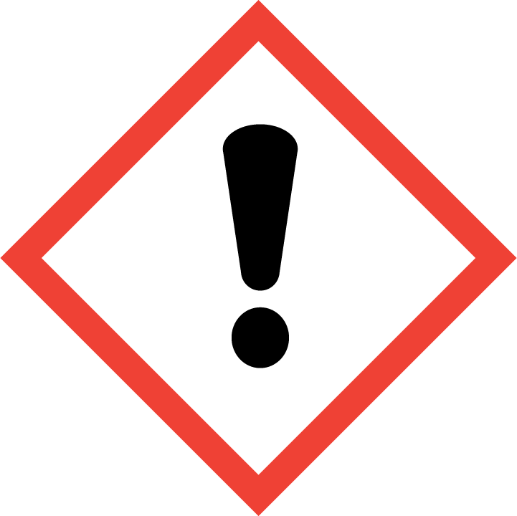 | 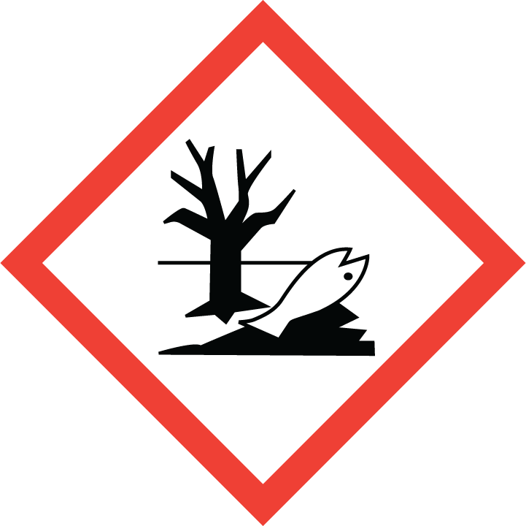

GHS Classification: | Hazardous to the aquatic environment - Acute Category 2; Hazardous to the aquatic environment - Chronic Category 2
GHS Signal Word: | Warning
GHS Hazard | May cause an allergic skin reaction.; Toxic to aquatic life..; Toxic to aquatic life with long lasting effects.
GHS Precautions:
Safety Precautions: | Contaminated work clothing should not be allowed out of the workplace. Avoid release to the environment. Wear protective gloves/protective clothing/eye protection/face protection.
First Aid Measures  (Response): | IF ON SKIN: Wash with plenty of soap and water. If skin irritation or rash occurs: Get medical advice/attention. Wash contaminated clothing before reuse. Collect spillage.
Disposal: | Dispose of contents/container in accordance with local/regional/national/international regulation for hazardous wastes.

III. COMPOSITION/INFORMATION ON INGREDIENTS
Chemical Name | CAS # | %
Ethyl methylphenylglycidate | 77-83-8 | 5 - 10
4H-Pyran-4-one, 2-ethyl-3-hydroxy- | 4940-11-8 | 3 - 7
2H-1-Benzopyran-2-one | 91-64-5 | 1 - 5
Cyclohexanepropanoic acid, 2-propen-1-yl ester | 2705-87-5 | 1 - 5
2-Propenoic acid, 3-phenyl-, methyl ester | 103-26-4 | 1 - 5
Hexanoic acid, 2-propen-1-yl ester | 123-68-2 | 1 - 5
Acetic acid, phenylmethyl ester | 140-11-4 | 0.5 - 1.5
The specific chemical identity and/or exact percentage (concentration) of composition has been withheld as a trade secret is required.

IV. FIRST-AID MEASURES
Inhalation: | Remove to fresh air. If breathing is difficult, have a trained individual administer oxygen. If not breathing, give artificial respiration and have a trained individual administer oxygen. Get medical attention immediately
Eyes: | Flush eyes with plenty of water for at least 20 minutes retracting eyelids often. Tilt the head to prevent chemical from transferring to the uncontaminated eye. Get immediate medical attention.
Skin Contact: | Wash with soap and water. Remove contaminated clothing and launder. Get medical attention if irritation develops or persists.
Ingestion: | Do not induce vomiting and seek medical attention immediately. Drink two glasses of water or milk to dilute. Provide medical care provider with this MSDS.
Most important symptoms and effects - acute | No Data Available
Most important symptoms and effects - chronic | No Data Available
Notes to Doctor: | No additional first aid information available

V. FIRE FIGHTING MEASURES
Flammability Summary: | Combustible at elevated temperatures
Extinguishing Media: | Use alcohol resistant foam, carbon dioxide, or dry chemical extinguishing agents. Water may be ineffective but water spray can be used extinguish a fire if swept across the base of the flames. Water can absorb heat and keep exposed material from being damaged by fire.
Extinguishing Media advised against: | No Data Available
Fire and/or Explosion Hazards: | Vapors may be ignited by sparks, flames or other sources of ignition if material is above the flash point giving rise to a fire (Class B). Vapors are heavier than air and may travel to a source of ignition and flash back. Empty containers that retain product residue (liquid, solid/sludge, or vapor) can be dangerous. Do not pressurize, cut, weld, braze, solder, drill, grind, or expose container to heat, flame, sparks, static electricity, or other sources of ignition. Any of these actions can potentially cause an explosion that may lead to injury or death.
Fire Fighting Methods and Protection: | Do not enter fire area without proper protection including self-contained breathing apparatus and full protective equipment. Fight fire from a safe distance and a protected location due to the potential of hazardous vapors and decomposition products. Use methods for the surrounding fire.
Hazardous Combustion Products: | Carbon dioxide, Carbon monoxide, Toxic fumes., Toxic gases, Carbon Oxides

VI. ACCIDENTAL RELEASE MEASURES
Personal Precautions and Equipment: | No health affects expected from the clean-up of this material if contact can be avoided. Follow personal protective equipment recommendations found in Section VIII of this MSDS
Methods for Clean-up: | No special spill clean-up considerations. Collect and discard in regular trash.

VII. HANDLING AND STORAGE
Handling Technical Measures and Precautions: | Mildly irritating material. Avoid unnecessary exposure. As with all chemicals, good industrial hygiene practices should be followed when handling this material. Avoid contact with material, avoid breathing dusts or fumes, use only in a well ventilated area. Wash thoroughly after handling Do not get in eyes, on skin and clothing Use spark-proof tools and explosion-proof equipment Keep in air-tight containers- material is hygroscopic. "Empty" containers retain product residue (liquid and/or vapor) and can be dangerous. Remove contaminated clothing and wash before reuse Use with adequate ventilation Ground and bond containers when transferring material
Storage Technical Measures and Conditions: | Store in a cool dry place. Isolate from incompatible materials. Store in a cool dry place Store in a tightly closed container Keep away from heat, sparks, and flame Keep away from sources of ignition Store in a cool place in original container and protect from sunlight Do not store near combustible materials
Materials to Avoid/Chemical Incompatibility: | Strong oxidizing agents Acetic anhydride Strong acids Strong reducing agents Chlorinated compounds Strong bases Acids Bases Reducing agents Strong alkalies Nitrogen oxides

VIII. EXPOSURE CONTROLS/PERSONAL PROTECTION
Engineering Measures: | No exposure limits exist for the constituents of this product. Use local exhaust ventilation or other engineering controls to minimize exposures and maintain operator comfort. Engineering controls must be designed to meet the OSHA chemical specific standard in 29 CFR 1910. Explosion proof exhaust ventilation should be used. Ventilation is required to maintain operator exposure below published exposure limits. Use process enclosures, local exhaust ventilation, or other engineering controls to control airborne levels below recommended exposure limits Facilities storing or using this material should be equipped with an eyewash and safety shower.

Respiratory Protection: | Respiratory protection may be required to avoid overexposure when handling this product. General or local exhaust ventilation is the preferred means of protection. Use a respirator if general room ventilation is not available or sufficient to eliminate symptoms. Follow a respiratory protection program that meets 29 CFR 1910.134 and ANSI Z88.2 requirements whenever work place conditions warrant the use of a respirator. Wear a NIOSH approved respirator if any exposure is possible.
Eye Protection: | Wear chemically resistant safety glasses with side shields when handling this product. Do not wear contact lenses. Wear goggles and a Face shield
Skin Protection: | Wear protective gloves. Inspect gloves for chemical break-through and replace at regular intervals. Clean protective equipment regularly. Wash hands and other exposed areas with mild soap and water before eating, drinking, and when leaving work Where contact is likely, wear chemical resistant gloves, a chemical suit, rubber boots, and chemical safety goggles plus a face shield
Gloves: | No information available
Handling Instructions: | As with all chemicals, good industrial hygiene practices should be followed when handling this material. Avoid contact with material, avoid breathing dusts or fumes, use only in a well ventilated area. Wash thoroughly after handling Do not get in eyes, on skin and clothing Use spark-proof tools and explosion-proof equipment Keep in air-tight containers- material is hygroscopic. "Empty" containers retain product residue (liquid and/or vapor) and can be dangerous. Remove contaminated clothing and wash before reuse Use with adequate ventilation Ground and bond containers when transferring material

Control Parameters:
Chemical Name | ACGIH TLV-TWA | ACGIH STEL | OSHA PEL
No Data Available

IX. PHYSICAL AND CHEMICAL PROPERTIES
Physical State: | Solid
Color: | Dark grey
Odor: | Mild Comparable to Standard
Odor Threshold: | ND
pH: | Not Available
Initial Boiling Point: | 250 - 252 º F
Flash Point: | > 200 º F
Evaporation Rate: | Not Available
Flammability (Solid, Gas): | No Data Available
Upper Flammable/Explosive Limit: | 9.0
Lower Flammable/Explosive Limit: | 1.3
Vapor Density: | > 1
Relative Density (Specific Gravity): | 0.9426
Solubility in Water: | Soluble in water- No
Octanol/Water Partition Coefficient: | 0.14 2.93 at 22 °C (72 °F) 2.62 3.2
Auto-ignition Temperature: | 259 º C
Volatiles, % by weight: | 5
Bulk Density: | 7.869

X. STABILITY AND REACTIVITY
Reactivity: | No Data Available
Chemical Stability: | Stable under normal conditions.
Possibility of Hazardous Reactions: | No Data Available
Conditions to Avoid: | Temperatures above the high flash point of this combustible material in combination with sparks, open flames, or other sources of ignition. Contamination Elevated temperatures Avoid moisture Heat flame sparks
Materials to Avoid/Chemical Incompatibility: | Strong oxidizing agents Acetic anhydride Strong acids Strong reducing agents Chlorinated compounds Strong bases Acids Bases Reducing agents Strong alkalies Nitrogen oxides
Hazardous Decomposition Products: | Carbon dioxide Carbon monoxide Toxic fumes. Toxic gases Carbon Oxides

XI. TOXICOLOGICAL INFORMATION
Routes of Entry: | Skin contact, Eye contact, Inhalation, Ingestion
Most Important Symptoms: | No Data Available
Target Organs Potentially Affected by Exposure: |  | Eyes, Nervous System, Respiratory Tract, Skin
Chemical Interactions That Change Toxicity: |  | None Known
Medical Conditions Aggravated by Exposure: |  | Eye disease, Respiratory disease including asthma and bronchitis, Skin disease including eczema and sensitization

Immediate (Acute) Health Effects by Route of Exposure:
 | Inhalation Irritation: | Can cause respiratory irritation.
 | Skin Contact: | Can cause moderate skin irritation, defatting, and dermatitis. Not likely to cause permanent damage.
 | Skin Absorption: | No absorption hazard in normal industrial use.
 | Eye Contact: | Can cause moderate irritation, tearing and reddening, but not likely to permanently injure eye tissue.
 | Ingestion Irritation: | Irritating to mouth, throat, and stomach. Can cause abdominal discomfort, nausea, vomiting and diarrhea.
 | Ingestion Toxicity: | Harmful if swallowed.
Long-Term (Chronic) Health Effects:
 | Carcinogenicity: | None of the substances have been shown to cause cancer in long term animal studies. Not a carcinogen according to NTP, IARC, or OSHA.
 | Reproductive toxicity: | No data available to indicate product or any components present at greater than 0.1% may cause birth defects.
 | Germ cell mutagenicity: | No data available to indicate product or any components present at greater than 0.1% is mutagenic or genotoxic.
 | Inhalation: | Upon prolonged and/or repeated exposure, can cause moderate respiratory irritation, dizziness, weakness, fatigue, nausea and headache.
 | Skin Contact: | Upon prolonged or repeated contact, can cause moderate skin irritation, defatting, and dermatitis. Not likely to cause permanent damage.
 | Skin Absorption: | Upon prolonged or repeated exposure, no hazard in normal industrial use.

Component Toxicology Data:
Chemical Name | CAS Number | LD50/LC50
No data available

Has the chemical been classified as a Carcinogen by NTP, IARC or OSHA.
Chemical Name | OSHA Carcinogen | IARC Carcinogen | NTP Carcinogen
No Data Available

XII. ECOLOGICAL INFORMATION
Overview: | This material is not expected to be harmful to the ecology.
Mobility in Soil: | No Data Available
Persistence: | No Data Available
Bioaccumulation: | No Data Available
Other adverse effects | No Data Available

Ecotoxicity Data
Chemical Name | CAS Number | Aquatic EC50 Crustacea | Aquatic ERC50 Algae | Aquatic LC50 Fish
No Data Available

XIII. DISPOSAL CONSIDERATIONS
Waste Description for Spent Product: | Spent or discarded material is not expected to be a hazardous waste.
Waste Description for Empty Packaging: | No Data Available
Disposal Methods: | DO NOT DUMP INTO ANY SEWERS, ON THE GROUND, OR INTO ANY BODY OF WATER. All disposal practices must be in compliance with all Federal, State/Provincial and local laws and regulations. Regulations may vary in different locations. Waste characterizations and compliance with applicable laws are the sole responsibility of the waste generator. As your supplier, we have no control over the management practices or manufacturing processes of parties handling or using this material. The information presented here pertains only to the product when used as intended, according to this MSDS. For unused and uncontaminated product, the preferred options include sending to a licensed and permitted incinerator or other thermal destruction device. Various federal, state or provincial agencies may have specific regulations concerning the transportation, handling, storage, use or disposal of this product which may not be covered in this MSDS. The user shall have to review these regulations to ensure full compliance with all applicable regulations.

XIV. TRANSPORTATION INFORMATION
US DOT Ground Shipping Description: | Not Restricted
IATA Shipping Description: | Not Restricted
IMDG Shipping Description: | Not Restricted

XV. REGULATORY INFORMATION
TSCA Status | All components in this product are on the TSCA Inventory.
California Prop 65 | Does not contain any chemicals listed on California Proposition 65.

Chemical Name | CAS # | Regulation | % Range
N590 Polycyclic aromatic compounds (PACs) | 91-64-5 | SARA 313 | 1 - 5

XVI. OTHER INFORMATION
Revision Date: | 09-11-2015
Disclaimer: | Important: While the descriptions, data and information contained herein are presented in good faith and believed to be accurate, it is provided for your guidance only. Because many factors may affect processing or application/use, we recommend that you perform an assessment to determine the suitability of the product for your particular purpose prior to use. Nothing herein should be interpreted as a recommendation to infringe existing patents or violate any laws or regulations. No warranties of any kind, either expressed or implied, including fitness for a particular purpose are made regarding the product described. We assume NO responsibility for any injuries resulting from misuse or misapplication of this product or that might be sustained because of inhalation, ingestion, absorption or other contact with this product. In no case shall the descriptions, information, or data provided be considered a part of our terms and conditions of sale. Further, the descriptions, data and information furnished hereunder are given gratis. No obligation or liability for the description, data and information given are assumed. All such being given and accepted at your risk.

